CSci 242: Algorithms and Data Structures Spring, 2020

Instructor: Dr. M. E. Kim Date: March 4th, 2020

Due: by the end of day, March 13th (Fri.), 2020.

Read the submission instructions carefully and comply with them.

**Home Assignment 4: 150 points + 20 (optional)**

Consider the keys, 3, 14, 18, 37, 9, 92, 21, 86, 11, 42, and 10. Insert them in a hash table of size 11 with the hash function, *h*(*k*) = (2*k* +5) mod 11. Collision is handled by each of the method in Q1 – Q4. Show the final content of hash table after insertion.

For each question, you have to show the proper computational steps.

Q1. [10] Collision handled by ***chaining***. Draw the final hash table after insertion.

|  |  |  |  |  |  |  |  |  |  |  |
| --- | --- | --- | --- | --- | --- | --- | --- | --- | --- | --- |
| **0** | **1** | **2** | **3** | **4** | **5** | **6** | **7** | **8** | **9** | **10** |
| 3 | 9 | 37 | 21 |  | 11 |  |  | 18 |  |  |
| 14 | 86 | 92 | 10 |  |  |  |  |  |  |  |
|  | 42 |  |  |  |  |  |  |  |  |  |

2(3) + 5 mod 11 = 0

2(14) + 5 mod 11= 0

2(18) + 5 mod 11 = 1

2(37) + 5 mod 11= 8

2(9)+ 5 mod 11 = 2

2(92) + 5 mod 11= 1

2(21) + 5 mod 11= 2

2(86)+ 5 mod 11 = 3

2(11) + 5 mod 11= 1

2(42) + 5 mod 11 = 5

2(10) + 5 mod 11 =1

Q2. [10] Collision handled by open addressing with the linear probing where probe function *f*(*j*) = *j.*

|  |  |  |  |  |  |  |  |  |  |  |
| --- | --- | --- | --- | --- | --- | --- | --- | --- | --- | --- |
| 0 | 1 | 2 | 3 | 4 | 5 | 6 | 7 | 8 | 9 | 10 |
| 3 | 14 | 37 | 9 | 92 | 21 | 86 | 11 | 18 | 42 | 10 |

2(3) + 5 mod 11 = 0

2(14) + 5 mod 11= 0

2(14) + 5 + 1 mod 11 = 1

2(18) + 5 mod 11 = 8

2(37) + 5 mod 11= 2

2(9)+ 5 mod 11 = 1

2(14) + 5 + 1 mod 11 = 2

2 (14) + 5 + 2 mod 11 = 3

2(92) + 5 mod 11= 2

2(92) + 5 + 1 mod 11 = 3

2(92) + 5 + 2 mod 11 = 4

2(21) + 5 mod 11= 3

2(21) + 5 + 1 mod 11 = 4

2(21) + 5+ 2 mod 11 = 5

2(86)+ 5 mod 11 = 1

2(86) + 5 + 1 mod 11= 2

2(86) + 5 + 2 mod 11= 3

2(86) + 5 + 3 mod 11= 4

2(86) + 5 + 4 mod 11= 5

2(86) + 5 + 5 mod 11= 6

2(11) + 5 mod 11= 5

2(11) + 5 + 1 mod 11 = 6

2(11) + 5 + 2 mod 11 = 7

2(42) + 5 mod 11 = 1

2(42) + 5 + 1 mod 11= 2

2(42) + 5 + 2 mod 11= 3

2(42) + 5 + 3 mod 11= 4

2(42) + 5 + 4 mod 11= 5

2(42) + 5 + 5 mod 11= 6

2(42) + 5 + 6 mod 11 = 7

2(42) + 5 + 7 mod 11 = 8

2(10) + 5 mod 11 = 3

2(10) + 5 + 1 mod 11= 4

2(10) + 5 + 2 mod 11= 5

2(10) + 5 + 3 mod 11= 6

2(10) + 5 + 4 mod 11= 7

2(10) + 5 + 5 mod 11= 8

2(10) + 5 + 6 mod 11 = 9

2(10) + 5 + 7 mod 11 = 10

Q3. [10] Collision handled by open addressing with the quadratic probing where the probe function *f*(*j*) = *j*2 + *j* Show the final hash table up to the point where the method fails because no empty slot is found.

|  |  |  |  |  |  |  |  |  |  |  |
| --- | --- | --- | --- | --- | --- | --- | --- | --- | --- | --- |
| 0 | 1 | 2 | 3 | 4 | 5 | 6 | 7 | 8 | 9 | 10 |
| 3 | 9 | 14 | 92 | 37 | 21 | 11 | 86 | 18 | 10 | 42 |

2(3) + 5 mod 11 = 0

2(14) + 5 mod 11= 0

33 + 2 mod 11 = 2

2(18) + 5 mod 11 = 8

2(37) + 5 mod 11= 2

79 + 2 mod 11 = 4

2(9)+ 5 mod 11 = 1

2(92) + 5 mod 11 = 2

189 + 2 mod 11 = 4

189 + 6 mod 11 = 8

189 + 12 mod 11 = 3

2(21) + 5 mod 11= 3

47 + 2 mod 11 = 5

2(86)+ 5 mod 11 = 1

177 + 2 mod 11 = 3

177 + mod 11 = 7

2(11) + 5 mod 11= 5

27 + 2 mod 11 = 7

27 + 6 mod 11 = 0

27 + 12 mod 11 = 6

2(42) + 5 mod 11 = 1

89 + 2 mod 11 = 3

89 + 6 mod 11 = 7

89 + 12 mod 11 = 2

89 + 20 mod 11 = 10

2(10) + 5 mod 11 = 3

25+ 2 mod 11 = 5

25+ 6 mod 11 = 9

Couldn’t add 10 or 42 because the modulo never lead to an open spot

Q4. [10] Collision handled by open addressing with the double hashing using a secondary hash function d(*k*) = 7 – (*k* mod 7).

|  |  |  |  |  |  |  |  |  |  |  |
| --- | --- | --- | --- | --- | --- | --- | --- | --- | --- | --- |
| 0 | 1 | 2 | 3 | 4 | 5 | 6 | 7 | 8 | 9 | 10 |
| 3 |  |  |  |  |  |  | 14 |  |  |  |

2(3) + 5 mod 11 = 0

2(14) + 5 mod 11= 0

2(18) + 5 mod 11 = 8

2(37) + 5 mod 11= 2

2(9)+ 5 mod 11 = 1

2(92) + 5 mod 11 = 2

2(21) + 5 mod 11= 3

2(86)+ 5 mod 11 = 1

2(11) + 5 mod 11= 5

2(42) + 5 mod 11 = 1

2(10) + 5 mod 11 = 3

7 – ( 3 mod 7 ) = 4

7 – 14 mod 7 = 7

7 – 18 mod 7 = 3

7 – 37 mod 7 = 5

7 – 9 mod 7 = 5

7 – 92 mod 7 = 6

7 – 21 mod 7 = 7

7 – 86 mod 7 = 5

7 – 11 mod 7 = 3

7 – 42mod 7 = 7

7 – 10 mod 7 = 4

Q5. [10] Collision handled by Cuckoo hashing using h1(k) = (2*k* +5) mod 11 and h2(k) = (3*k*+1) mod 11 the hash tables T1 and T2, respectively.

T1 :

|  |  |  |  |  |  |  |  |  |  |  |
| --- | --- | --- | --- | --- | --- | --- | --- | --- | --- | --- |
| 0 | 1 | 2 | 3 | 4 | 5 | 6 | 7 | 8 | 9 | 10 |
| 14 | 86 | 37 | 10 |  | 11 |  |  | 18 |  |  |

Infinity loop between 86 – 9 – 14

T2 :

|  |  |  |  |  |  |  |  |  |  |  |
| --- | --- | --- | --- | --- | --- | --- | --- | --- | --- | --- |
| 0 | 1 | 2 | 3 | 4 | 5 | 6 | 7 | 8 | 9 | 10 |
|  |  | 92 |  |  |  | 9 |  |  | 21 | 10 |

H1 =

2(3) + 5 mod 11 = 0

2(14) + 5 mod 11= 0

2(18) + 5 mod 11 = 8

2(37) + 5 mod 11= 2

2(9)+ 5 mod 11 = 1

2(92) + 5 mod 11 = 2

2(21) + 5 mod 11= 3

2(86)+ 5 mod 11 = 1

2(11) + 5 mod 11= 5

2(42) + 5 mod 11 = 1

2(10) + 5 mod 11 = 3

H2 =

3(3) + 1 mod 11 = 10

3(14) + 1 mod 11 = 9

3(18) + 1 mod 11 = 0

3(37) + 1 mod 11 = 2

3(9) + 1 mod 11 = 6

3(92) + 1 mod 11 = 2

3(21) + 1 mod 11 = 9

3(86) + 1 mod 11 = 6

3(11) + 1 mod 11 = 1

3(42) + 1 mod 11 = 6

3(10) + 1 mod 11 = 9

Q6. [15 * 5 = 75] Implementation of Q1 – Q5

Implement the insertion algorithms with the given keys in Q1 – Q5 for each collision handling scheme.

Print the final content of hash table: e.g.) (slot #, (a list of) key)

Chaining :

Linear :

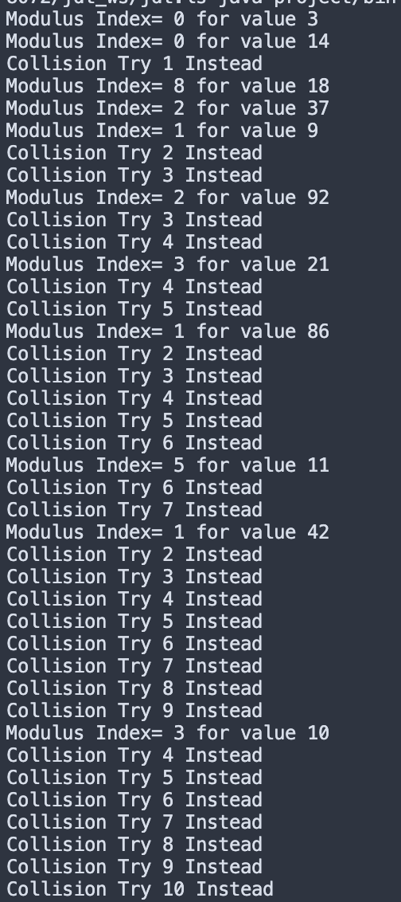

Quadratic Hashing :

Double Hashing :

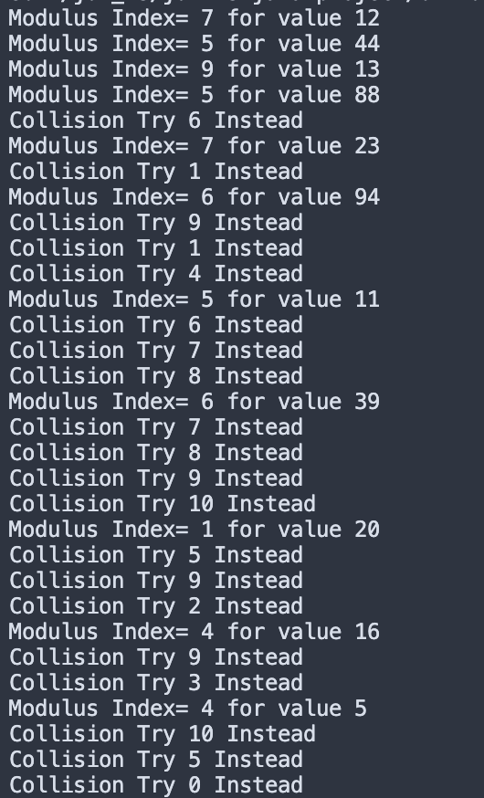

Cuckoo Hashing :

Q7. [25] Implementation of removal of key.

From the final heap in Q2, remove each key in the order of its insertion, i.e. 3, 14, 18, ….

After each removal of a key, print the content of the hash table after filing the empty slots:

e.g.) After removal of 3: A table of (slot #, key)

Q8. [10, optional]

In the hashing technique with linear probing, the ***remove*(*k*)** method is designed with ***Shift(i)*** method to fill the holes after the removal of a key in the slot *i*. In the hashing with quadratic probing, how would you handle the such a problem caused by the removal of a key? Explain your idea and design its algorithm. Suppose the probe function is *f*(*j*) = *j*2 is used for the quadratic probing.

**I would rehash the table using the original function and any clashes would use the auxiliary function.**

**This would allow the table to be shifted after the removal of a key.**

**Algorithm rehash**

**Input: array, k**

**Output: index**

**index = 2k + 5 mod 11**

**While array != null do**

**Index = (2k + 5 + k2 ) mod 11**

**Output index**

Q9 [10, optional]

Implement your algorithm in Q8 by removing each from the final heap of Q3. Print the hash table after each removal.

**I hit an infinite loop and have been unable to figure out how to force it into completion, thus is why I did not include a screenshot of it.**